Quantitative ability
[50 questions]

- Let A and B be two solid spheres such that the surface area of B is 300% higher than the surface area of A. The volume of A is found to be k% lower than the volume of B. The value of k must be
1. 85.5 2. 92.5 3. 90.5 4. 87.5

Soln. (4) — The surface area of a sphere is proportional to the square of the radius.
Thus, 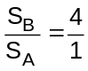 (S. A. of B is 300% higher than A)
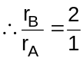
The volume of a sphere is proportional to the cube of the radius.
Thus, 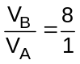
Or, V_{A} is 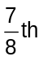 less than B i.e. 87.5%

- A test has 50 questions. A student scores 1 mark for a correct answer, –1/3 for a wrong answer, and –1/6 for not attempting a question. If the net score of a student is 32, the number of questions answered wrongly by that student cannot be less than
1. 6 2. 12 3. 3 4. 9

Soln. (3) — Let the number of correct answers be ‘x’, number of wrong answers be ‘y’ and number of questions not attempted be ‘z’.
Thus, x + y + z = 50 … (i)
And 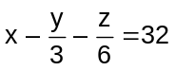
The second equation can be written as,
6x – 2y – z = 192 … (ii)
Adding the two equations we get,
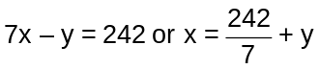
Since, x and y are both integers, y cannot be 1 or 2. The minimum value that y can have is 3.

- The sum of 3rd and 15th elements of an arithmetic progression is equal to the sum of 6th, 11th and 13th elements of the same progression. Then which element of the series should necessarily be equal to zero?
1. 1st 2. 9th 3. 12th 4. None of the above

Soln. (3) — If we consider the third term to be ‘x”
The 15th term will be (x + 12d)
6th term will be (x + 3d)
11th term will be (x + 8d) and 13th term will be (x + 10d)
Thus, as per the given condition, 2x + 12d = 3x + 21d.
Or x + 9d = 0
x + 9d will be the 12th term.

- When the curves y = log₁₀x and y = x^{–1} are drawn in the x–y plane, how many times do they intersect for values 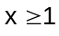?
1. Never 2. Once 3. Twice 4. More than twice

Soln. (2) — For the curves to intersect, 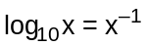
Thus, 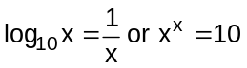
This is possible for only one value of x (2< x < 3).

- At the end of year 1998, Shepard bought nine dozen goats. Henceforth, every year he added p% of the goats at the beginning of the year and sold q% of the goats at the end of the year where p>0 and q>0. If Shepard had nine dozen goats at the end of year 2002, after making the sales for that year, which of the following is true?
1. p = q 2. p < q 3. p > q 4. p = q/2

Soln. (3) — The number of goats remain the same.
If the percentage that is added every time is equal to the percentage that is sold, then there should be a net decrease. The same will be the case if the percentage added is less than the percentage sold.
The only way, the number of goats will remain the same is if p > q.

- A leather factory produces two kinds of bags, standard and deluxe. The profit margin is Rs. 20 on a standard bag and Rs. 30 on a deluxe bag. Every bag must be processed on machine A and on Machine B. The processing times per bag on the two machines are as follows:

 | Time required (Hours/bag)
 | Machine A | Machine B
Standard Bag | 4 | 6
Deluxe Bag | 5 | 10

The total time available on machine A is 700 hours and on machine B is 1250 hours. Among the following production plans, which one meets the machine availability constraints and maximizes the profit?
1. Standard 75 bags, Deluxe 80 bags 2. Standard 100 bags, Deluxe 60 bags
3. Standard 50 bags, Deluxe 100 bags 4. Standard 60 bags, Deluxe 90 bags

Soln. (1) — Let ‘x’ be the number of standard bags and ‘y’ be the number of deluxe bags.
Thus, 4x + 5y 700 and 6x + 10y 1250
Among the choices, 3 and 4 do not satisfy the second equation.
Choice 2 is eliminated as, in order to maximize profits the number of deluxe bags should be higher than the number of standard bags.

- The function f(x) = |x – 2| + |2.5 – x| + |3.6 – x|, where x is a real number, attains a minimum at
1. x = 2.3 2. x = 2.5 3. x = 2.7 4. None of the above

Soln. (2) — Case 1: If x < 2, then y = 2 – x + 2.5 – x + 3.6 – x = 8.1 – 3x.
This will be least if x is highest i.e. just less than 2.

In this case y will be just more than 2.1

Case 2: If 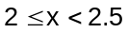, then y = x – 2 + 2.5 – x 3.6 – x = 4.1 – x
Again, this will be least if x is the highest case y will be just more than 1.6.

Case 3: If 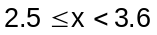, then y = x – 2 + x – 2.5 + 3.6 – x = x – 0.9
This will be least if x is least i.e. X = 2.5.

Case 4: If In this case y = 1.6 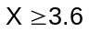, then
y = x – 2 + x – 2.5 + x – 3.6 = 3x – 8.1
The minimum value of this will be at x = 3.6 = 27
Hence the minimum value of y is attained at x = 2.5

- In a 4000 meter race around a circular stadium having a circumference of 1000 meters, the fastest runner and the slowest runner reach the same point at the end of the 5th minute, for the first time after the start of the race. All the runners have the same staring point and each runner maintains a uniform speed throughout the race. If the fastest runner runs at twice the speed of the slowest runner, what is the time taken by the fastest runner to finish the race?
1. 20 min 2. 15 min 3. 10 min 4. 5 min

Soln. (3) — The ratio of the speeds of the fastest and the slowest runners is 2 : 1. Hence they should meet at only one point on the circumference i.e. the starting point (As the difference in the ratio in reduced form is 1). For the two of them to meet for the first time, the faster should have completed one complete round over the slower one. Since the two of them meet for the first time after 5 min, the faster one should have completed 2 rounds (i.e. 2000 m) and the slower one should have completed 1 round. (i.e. 1000 m) in this time. Thus, the faster one would complete the race (i.e. 4000 m) in 10 min.

- A positive whole number M less than 100 is represented in base 2 notation, base 3 notation, and base 5 notation. It is found that in all three cases the last digit is 1, while in exactly two out of the three cases the leading digit is 1. Then M equals
1. 31 2. 63 3. 75 4. 91

Soln. (4) — Since the last digit in base 2, 3 and 5 is 1, the number should be such that on dividing by either 2, 3 or 5 we should get a remainder 1. The smallest such number is 31. The next set of numbers are 61, 91.
Among these only 31 and 91 are a part of the answer choices.
Among these,
Thus, all three forms have leading digit 1.
Hence the answer is 91.

- Which one of the following conditions must p, q and r satisfy so that the following system of linear simultaneous equations has at least one solution, such that p + q + r 0?
x+ 2y – 3z = p
2x + 6y – 11z = q
x – 2y + 7z = r
1. 5p –2q – r = 0 2. 5p + 2q + r = 0 3. 5p + 2q – r = 0 4. 5p – 2q + r = 0

Soln. (1) — It is given that 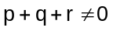, if we consider the first option, and multiply the first equation by 5, second by –2 and third by –1, we see that the coefficients of x, y and z all add up-to zero.
Thus, 5p – 2q – r = 0
No other option satisfies this.

- How many even integers n, where 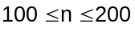, are divisible neither by seven nor by nine?
1. 40 2. 37 3. 39 4. 38

Soln. (3) — There are 101 integers in all, of which 51 are even.
From 100 to 200, there are 14 multiples of 7, of which 7 are even.
There are 11 multiples of 9, of which 6 are even.
But there is one integer (i.e. 126) that is a multiple of both 7 and 9 and also even.
Hence the answer is (51 – 7 – 6 + 1) = 39

- Twenty-seven persons attend a party. Which one of the following statements can never be true?
- There is a person in the party who is acquainted with all the twenty-six others.
- Each person in the party has a different number of acquaintances.
- There is a person in the party who has an odd number of acquaintances.
- In the party, there is no set of three mutual acquaintances.

Soln. (2) — The number 27 has no significance here. Statement 2, will never be true for any number of people.
Let us the case of 2 people.
If A knows B and B only knows A, both of them have 1 acquaintance each. Thus, B should be knowing atleast one other person.
Let us say he knows ‘C’ as well. So now ‘B’ has two acquaintances (A and C), but C has only acquaintance (B), which is equal to that of A.
To close this loop, C will have to know A as well. In which case he will have two acquaintances, which is the same as that of C.
Thus the loop will never be completed unless atleast two of them have the same number of acquaintances.
Besides, statements 1, 3 and 4 can be true.

Note: If we consider the other wise, to satisfy condition 2, the first person must have 26 acquaintances, the second 25, third 24 and so on. If we continue, the last one should have 0 acquaintance, which is not possible.

- Let g(x) = max(5 – x, x + 2). The smallest possible value of g(x) is
1. 4.0 2. 4.5 3. 1.5 4. None of the above

Soln. (4) — We can see that x + 2 is an increasing function and 5 – x is a decreasing function. This system of equation will have smallest value at the point of intersection of the two. i.e. 5 – x = x + 2 or x = 1.5. Thus smallest value of g(x) = 3.5

Directions for next two questions: Answer the questions on the basis of the information given below.

New Age Consultants have three consultants Gyani, Medha and Buddhi. The sum of the number of projects handled by Gyani and Buddhi individually is equal to the number of projects in which Medha is involved. All three consultants are involved together in 6 projects. Gyani works with Medha in 14 projects. Buddhi has 2 projects with Medha but without Gyani, and 3 projects with Gyani but without Medha. The total number of projects for New Age Consultants is one less than twice the number of projects in which more than one consultant is involved.

- What is the number of projects in which Medha alone is involved?
1. Uniquely equal to zero. 2. Uniquely equal to 1.
3. Uniquely equal to 4. 4. Cannot be determined uniquely.

6
8
3
2
Giani
Medha
Buddhi
G
M
B

Soln. (2) — As per the given data we get the following:

G + B = M + 16

Also, M + B + G + 19 = (2 x 19) – 1

i.e. (G + B) = 18 – M

Thus, M + 16 = 18 – M

i.e. M = 1

Q. What is the number of projects in which Gyani alone is involved?
1. Uniquely equal to zero. 2. Uniquely equal to 1.
3. Uniquely equal to 4. 4. Cannot be determined uniquely.

Soln. (4) — Putting the value of M in either equation, we get G + B = 17.
Hence neither of two can be uniquely determined.

- Given that , then which of the following is necessarily true?
1. 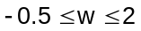 2. 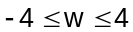 3. 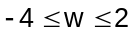 4. 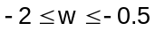

Soln. (2) — u is always negative. Hence, for us to have a minimum value of vz/u, vz should be positive. Also for the least value, the numerator has to be the maximum positive value and the denominator has to be the smallest negative value. In other words, vz has to be 2 and u has to be –0.5. Hence the minimum value of vz/u = 2/–0.5 = –4.
For us to get the maximum value, vz has to be the smallest negative value and u has to be the highest negative value. Thus, vz has to be –2 and u has to be –0.5. Hence the maximum value of vz/u = –2/–0.5 = 4.

Q. If the product of n positive real numbers is unity, then their sum is necessarily
1. a multiple of n 2. equal to 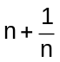
3. never less than n 4. a positive integer

Soln. (3) — The best way to do this is to take some value and verify.
E.g. 2, 1/2 and 1. Thus, n = 3 and the sum of the three numbers = 3.5.
Thus options 1, 2 and 4 get eliminated.

- There are 8436 steel balls, each with a radius of 1 centimeter, stacked in a pile, with 1 ball on top, 3 balls in the second layer, 6 in the third layer, 10 in the fourth, and so on. The number of horizontal layers in the pile is
1. 34 2. 38 3. 36 4. 32

Soln. (3) — Assume the number of horizontal layers in the pile be n.
So 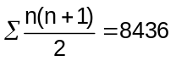
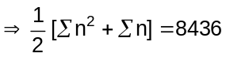
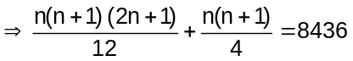
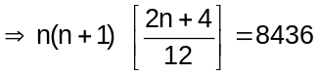
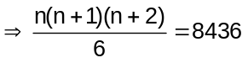
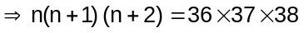
So n = 36

- In the figure below, the rectangle at the corner measures 10 cm × 20 cm. The corner A of the rectangle is also a point on the circumference of the circle. What is the radius of the circle in cm?

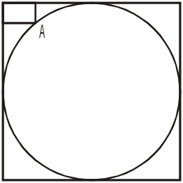

1. 10 cm 2. 40 cm 3. 50 cm d. None of the above.

Soln. (3) —

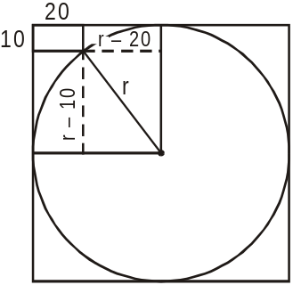

Let the radius be r. Thus we have (r – 10)² + (r – 20)² = r²
i.e. r² – 60r + 500 = 0. Thus r = 10 or 50.
It would be 10, if the corner of the rectangle had been lying on the inner circumference. But as per the given diagram, the radius of the circle should be 50 cm.

- A vertical tower OP stands at the center O of a square ABCD. Let h and b denote the length OP and AB respectively. Suppose 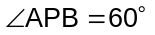 then the relationship between h and b can be expressed as
1. 2b² = h² 2. 2h² = b² 3. 3b² = 2h² 4. 3h² = 2b²

Soln. (2) —

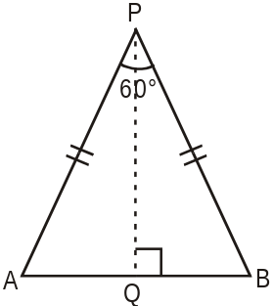
Given 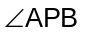= 60° and AB = b.
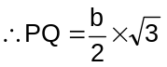
Next, 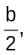 h and PQ form a right angle triangle.
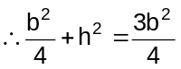
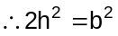

- How many three digit positive integers, with digits x, y and z in the hundred’s, ten’s and unit’s place respectively, exist such that x < y, z < y and 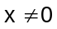?
1. 245 2. 285 3. 240 4. 320

Soln. (3) — If y = 2 (it cannot be 0 or 1), then x can take 1 value and z can take 2 values.
Thus with y = 2, a total of 1 X 2 = 2 numbers can be formed. With y = 3, 2 X 3 = 6 numbers can be formed. Similarly checking for all values of y from 2 to 9 and adding up we get the answer as 240.

Q. In the figure below, AB is the chord of a circle with center O. AB is extended to C such that BC = OB. The straight line CO is produced to meet the circle at D. If 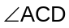= y degrees and 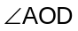= x degrees such that x = ky, then the value of k is
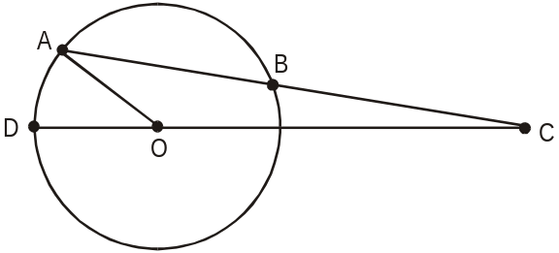
1. 3 2. 2 3. 1 4. None of the above.

Soln. (1) — If y = 10º,
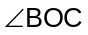 = 10º (opposite equal sides)
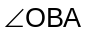 = 20º (external angle of 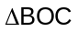)
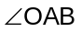 = 20 (opposite equal sides)
= 30º (external angle of 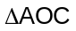)
Thus k = 3

Q. If log ₃ 2, log ₃ (2^{x} – 5), log ₃ (2^{x} – 7/2) are in arithmetic progression, then the value of x is equal to
1. 5 2. 4 3. 2 4. 3

Soln. (3) — Using log a – log b = log a/b, 2 / (y–5) = (y–5)/(y–3.5) where y = 2^{x}
Solving we get y = 4 or 8 i.e. x = 2 or 3. It cannot be 2 as log of negative number is not defined (see the second expression).

Q. In the diagram given below, . If AB:CD = 3:1, the ratio of CD: PQ is
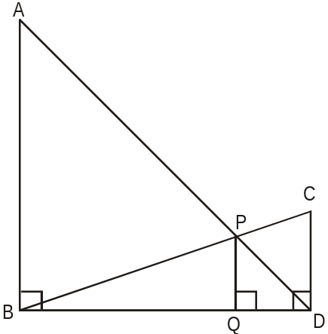

1. 1 : 0.69 2. 1 : 0.75 3. 1 : 0.72 4. None of the above.

Soln. (2) — Using the Basic Proportionality Theorem, AB/PQ = BD/QD and PQ/CD = BQ/BD. Multiplying the two we get, AB/CD = BQ/QD = 3 : 1.
Thus CD : PQ = BD : BQ = 4 : 3 = 1 : 0.75

Q. In the triangle ABC, AB = 6, BC = 8 and AC = 10. A perpendicular dropped from B, meets the side AC at D. A circle of radius BD (with center B) is drawn. If the circle cuts AB and BC at P and Q respectively, the AP:QC is equal to
1. 1:1 2. 3:2 3. 4:1 4. 3:8

Soln. (4) —
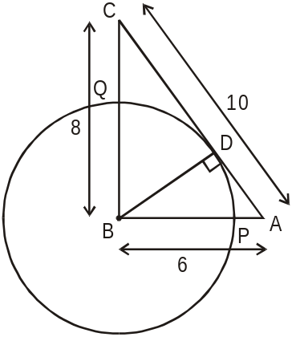
Triangle ABC is a right angled triangle.

Thus 1/2 × BC × AB = 1/2 × BD × AC
Or, 6 × 8 = BD × 10. Thus BD = 4.8. Therefore, BP = BQ = 4.8.
So, AP = AB – BP = 6 – 4.8 = 1.2 and CQ = BC – BQ = 8 – 4.8 = 3.2.
Thus, AP : CQ = 1.2 : 3.2 = 3 : 8

Q. Each side of a given polygon is parallel to either the X or the Y axis. A corner of such a polygon is said to be convex if the internal angle is 90° or concave if the internal angle is 270°. If the number of convex corners in such a polygon is 25, the number of concave corners must be
1. 20 2. 0 3. 21 4. 22

Soln. (3) — In this kind of polygon, the number of convex angles will always be exactly 4 more than the number of concave angles (why?).

Note : The number of vertices should be even. Hence the number of concave and convex corners should add up to an even number. This is true only for the answer choice 3.

Q. Let p and q be the roots of the quadratic equation 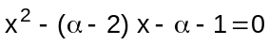. What is the minimum possible value of p² + q²?
1. 0 2. 3 3. 4 4. 5

Soln. (4) — p + q = α–2 and pq = –α – 1
(p + q)² = p² + q² + 2pq,
Thus (α–2)² = p² + q² + 2(–α– 1)
p² + q² = α² – 4α + 4 +2α + 2
p² + q² = α² – 2α + 6
p² + q² = α² – 2α + 1 + 5
p² + q² = (α² – 1)² + 5
Thus, minimum value of p² + q² is 5.

Q. The 288th term of the series a,b,b,c,c,c,d,d,d,d,e,e,e,e,e,f,f,f,f,f,f… is
1. u 2. v 3 w 4. x

Soln. (4) — The number of terms of the series forms the sum of first n natural numbers i.e.
n(n + 1)/2.
Thus the first 23 letters will account for the first (23 x 24)/2 = 276 terms of the series.
The 288th term will be the 24th letter viz. x.

Q. There are two concentric circles such that the area of the outer circle is four times the area of the inner circle. Let A, B and C be three distinct points on the perimeter of the outer circle such that AB and AC are tangents to the inner circle. If the area of the outer circle is 12 square centimeters then the area (in square centimeters) of the triangle ABC would be
1. 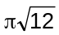 2. 3. 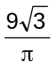 4 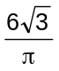

Soln. (3) —

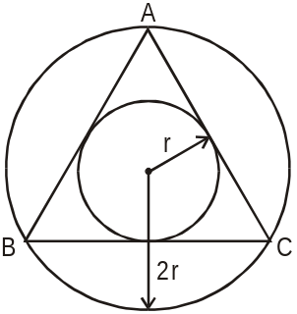

Since the area of the outer circle is 4 times the area of the inner circle, the radius of the outer circle should be 2 times that of the inner circle.
Since AB and AC are the tangents to the inner circle, they should be equal. Also, BC should be a tangent to inner circle. In other words, triangle ABC should be equilateral.
The area of the outer circle is 12. Hence the area of inner circle is 3 or the radius is 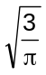 The area of equilateral triangle = 3√3 r², where r is the inradius.
Hence the answer is 9√3/π

Q. Let a, b, c, d be four integers such that a+b+c+d = 4m+1 where m is a positive integer. Given m, which one of the following is necessarily true?
1. The minimum possible value of a² + b² + c² + d² is 4m²–2m+1
2. The minimum possible value of a² + b² + c² + d² is 4m²+2m+1
3. The maximum possible value of a² + b² + c² + d² is 4m²–2m+1
4. The maximum possible value of a² + b² + c² + d² is 4m²+2m+1

Soln. (2) — (a + b + c + d)² = (4m + 1)²
Thus, a² + b² + c² + d² + 2(ab + ac + ad + bc + bd + cd) = 16m² + 8m + 1
a² + b² + c² + d² will have the minimum value if (ab + ac + ad + bc + bd + cd) is the maximum.
This is possible if a = b = c = d = (m + 0.25) ……….since a + b + c + d = 4m + 1
In that case 2((ab + ac + ad + bc + bd + cd) = 12(m + 0.25)² = 12m² + 6m + 0.75 Thus, the minimum value of a² + b² + c² + d² = (16m² + 8m + 1) – 2(ab + ac + ad + bc + bd + cd)
= (16m² + 8m + 1) – (12m² + 6m + 0.75)
= 4m² + 2m + 0.25
Since it is an integer, the actual minimum value = 4m² + 2m + 1

Q. In the figure below, ABCDEF is a regular hexagon and 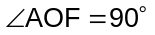. FO is parallel to ED. What is the ratio of the area of the triangle AOF to that of the hexagon ABCDEF?
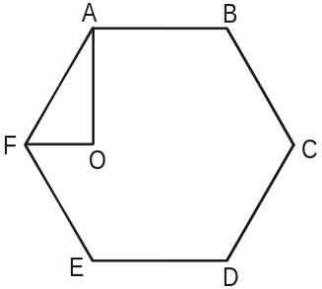

1. 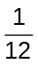 2. 3. 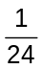 4. 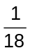

Soln. (1) — It is very clear, that a hexagon can be divided into six equilateral triangles. And triangle AOF is half of an equilateral triangle. Hence the required ratio = 1 : 12

Q. The number of non-negative real roots of 2^{x} – x – 1 = 0 equals
1. 0 2. 1 3. 2 4. 3

Soln. (3) — 2^{x} – x – 1 = 0
2^{x} – 1 = x
If we put x = 0, then this is satisfied and we put x = 1, then this is also satisfied.
Now we put x = 2, then this is not valid.

Q. Three horses are grazing within a semi-circular field. In the diagram given below, AB is the diameter of the semi-circular field with center at O. Horses are tied up at P, R and S such that PO and RO are the radii of semi-circles with centers at P and R respectively, and S is the center of the circle touching the two semi-circles with diameters AO and OB. The horses tied at P and R can graze within the respective semi-circles and the horse tied at S can graze within the circle centred at S. The percentage of the area of the semi-circle with diameter AB that cannot be grazed by the horses is nearest to

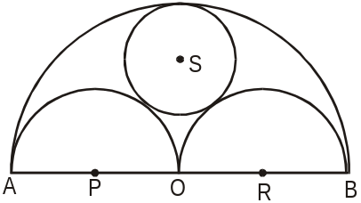

1. 20 2. 28 3. 36 4. 40

Soln. (3) — If the radius of the field is r, then the total area of the field = πr²/2.
The radius of the semi-circles with centre’s P and R = r/2.
Hence, their total area = π r²/4
Let the radius if the circle with centre S be x. Thus, OS = (r – x), OR = r/2 and RS = (r/2 + x). Applying Pythagoras theorem, we get (r – x)² + (r/2)² = (r/2 + x)²
Solving this, we get x = r/3.
Thus the area of the circle with centre S = π r²/9.
The total area that can be grazed = π r²(1/4 + 1/9) = 13π r²/36
Thus the fraction of the field that can be grazed = 26/36 (area that can be grazed / area of the field)
The fraction that cannot be grazed = 10/36 = 28% (approx.)

DIRECTIONS for next three questions: Answer the questions on the basis of the information given below.
A city has two perfectly circular and concentric ring roads, the outer ring road (OR) being twice as long as the inner ring road (IR). There are also four (straight line) chord roads from E1, the east end point of OR to N2, the north end point of IR; from N1, the north end point of OR to W2, the west end point of IR; from W1, the west end point of OR, to S2, the south end point of IR; and from S1 the south end point of OR to E2, the east end point of IR. Traffic moves at a constant speed of 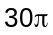 km/hr on the OR road, 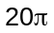 km/hr on the IR road, and 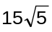 km/hr on all the chord roads.

Q1. Amit wants to reach N2 from S1. It would take him 90 minutes if he goes on minor arc S1 – E1 on OR, and then on the chord road E1 – N2. What is the radius of the outer ring road in kms?
1. 60 2. 40 3. 30 4. 20

Q2. Amit wants to reach E2 from N1 using first the chord N1 – W2 and then the inner ring road. What will be his travel time in minutes on the basis of information given in the above question?
1. 60 2. 45. 3. 90 4. 105

Q3. The ratio of the sum of the lengths of all chord roads to the length of the outer ring road is
1. 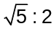 2. 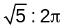 3. 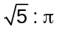 4. None of the above.

Soln. — 1. (3), 2 (4), 3. (3)

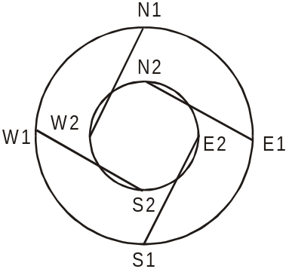

If the radius of the inner ring road is r, then the radius of the outer ring road will be 2r (since the circumference is double).
The length of IR = 2π r, that of OR = 4π r and that of the chord roads are r√5 (Pythagoras theorem)
The corresponding speeds are 20π, 30π and 15√5 kmph.
Thus time taken to travel one circumference of IR = (r/10) hr., one circumference of OR = (r/7.5) hr. and one length of the chord road = r/15

1. The total time taken by the route given = (r/30) + (r/15) = 3/2 (i.e. 90 min.)

Thus, r = 15 km. The radius of OR = 2r = 30 kms

2. The total time taken = (r/20) + r/15 = 7r/60.
Since r = 15, total time taken = 7/4 hr. = 105 min.

3. Sum of the length of the chord roads = 4r√5 and the length of OR = 4π r.
Thus the required ratio = √5 : π

Q. The number of positive integers n in the range 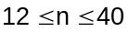 such that the product 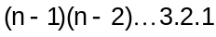 is not divisible by n is
1. 5 2. 7 3. 13 4. 14

Soln. (2) — From 12 to 40, there are 7 prime number, i.e. 13, 17, 19, 23, 29, 31, 37, which is not divisible by (n–1)!
Q. If x, y, z are distinct positive real numbers the
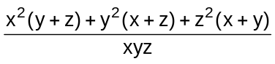 would be
1. greater than 4. 2. greater than 5. 3. greater than 6 4. None of the above.

Soln. (3) — Here x, y, z are distinct positive real number
So 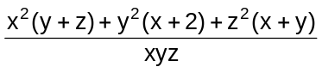
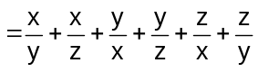
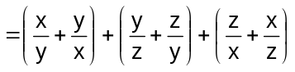[We know that 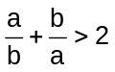 if a and b are distinct numbers
> 2 + 2 + 2
> 6

Q. In a certain examination paper, there are n questions. For j = 1,2 …n, there are 2^{n–j} students who answered j or more questions wrongly. If the total number of wrong answers is 4095, then the value of n is
1. 12 2. 11 3. 10 4. 9

Soln. (1) — Let us say there are only 3 questions. Thus there are 2^{3–1} = 4 students who have done 1 or more questions wrongly, 2^{3–2} = 2 students who have done 2 or more questions wrongly and 2^{3–3} = 1 student who must have done all 3 wrongly. Thus total number of wrong answers = 4 + 2 + 1 = 7 = 2³ – 1 = 2^{n} – 1.
In our question, the total number of wrong answers = 4095 = 2¹² – 1. Thus n = 12.

Q. Consider the following two curves in the x-y plane:
y = x³ + x² + 5
y = x² + x + 5

Which of following statements is true for 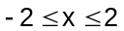?
1. The two curves intersect once. 2. The two curves intersect twice.
3. The two curves do not intersect 4. The two curves intersect thrice.

Soln. (4) — When we substitute two values of x in the above curves, at x = –2 we get
y = –8 + 4 + 5 = 1
y = 4 – 2 + 5 = 7
Hence at x = –2 the curves do not intersect.
At x = 2, y = 17 and y = 11
At x = –1, y = 5 and 5
When x = 0, y = 5 and y = 5
And at x = 1, y = 7 and y = 7
Therefore, the two curves meet thrice when x = –1, 0 and 1.

Q. Let T be the set of integers {3,11,19,27,…451,459,467} and S be a subset of T such that the sum of no two elements of S is 470. The maximum possible number of elements in S is
1. 32 2. 28 3. 29 4. 30

Soln. (4) – T_{n} = a + (n – 1)d
467 = 3 + (n – 1)8
n = 59
Half of n = 29 terms
29th term is 227 and 30th term is 243 and when these two terms are added the sum is more than 470.
Hence the maximum possible values the set S can have are 30.

Q. A graph may be defined as a set of points connected by lines called edges. Every edge connects a pair of points. Thus, a triangle is a graph with 3 edges and 3 points. The degree of a point is the number of edges connected to it. For example, a triangle is a graph with three points of degree 2 each. Consider a graph with 12 points. It is possible to reach any point from any point through a sequence of edges. The number of edges, e, in the graph must satisfy the condition
1. 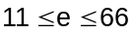 2. 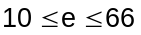 3. 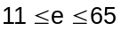 4. 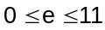

Soln. (1) —The least number of edges will be when one point is connected to each of the other 11 lines, giving a total of 11 lines. One can move from any point to any other point via the common point. The maximum edges will be when a line exists between any two points. Two points can be selected from 12 points in ¹²C₂ i.e. 66 lines.

Q. There are 6 boxes numbered 1,2,… 6. Each box is to be filled up either with a red or a green ball in such a way that at least 1 box contains a green ball and the boxes containing green balls are consecutively numbered. The total number of ways in which this can be done is
1. 5 2. 21 3. 33 4. 60

Soln. (2) — GRRRRR, RGRRRR, RRGRRR, RRRGRR, RRRRGR, RRRRRG

GGRRRR, RGGRRR, RRGGRR, RRRGGR, RRRRGG
GGGRRR, RGGGRR, RRGGGR, RRRGGG
GGGGRR, RGGGGR, RRGGGG
GGGGGR, RGGGGG
GGGGGG
Hence 21 ways.

DIRECTIONS for next two questions: Answer the questions on the basis of the information given below.

A certain perfume is available at a duty-free shop at the Bangkok international airport. It is priced in the Thai currency Baht but other currencies are also acceptable. In particular, the shop accepts Euro and US Dollar at the following rates of exchange:

US Dollar 1 = 41 Bahts
Euro 1 = 46 Bahts

The perfume is priced at 520 Bahts per bottle. After one bottle is purchased, subsequent bottles are available at a discount of 30%. Three friends S, R and M together purchase three bottles of the perfume, agreeing to share the cost equally. R pays 2 Euros. M pays 4 Euros and 27 Thai Bahts and S pays the remaining amount in US Dollars.

Q1. How much does M owe to S in US Dollars?
1. 3 2. 4 3. 5 4. 6

Q2. How much does R owe to S in Thai Baht?
1. 428 2. 416 3. 334 4. 324

Soln. — 1. (3) and 2. (4)

S, M and R in all spend 1248 bahts.
Initially M pays 211 bahts and R pays 92 bahts.
Remaining is born by S i.e; 945 bahts
If 1248 is divided equally among S,M and R each has to spend 415 bahts
Hence M has to pay S 205 bahts which is 5 Dollars.
And R has to pay 324 bahts to S.

DIRECTIONS for next five questions: Each question is followed by two statements, A and B. Answer each question using the following instructions.

Choose 1 if the question can be answered by one of the statements alone but not by the other.
Choose 2 if the question can be answered by using either statement alone.
Choose 3 if the question can be answered by using both the statements together, but cannot be answered by using either statement alone.
Choose 4 if the question cannot be answered even by using both the statements together.

Q. Is a⁴⁴ < b¹¹, given that a = 2 and b is an integer?
A. b is even
B. b is greater than 16

Soln. (1) — Solution cannot be found by using only Statement A since b can take any even number 2,4,6 …….. But we can arrive at solution by using statement B alone.

If b > 16, say b = 17
Hence 2⁴⁴ < (16 + 1)¹¹
2⁴⁴ < (2⁴ + 1)¹¹

Q. What are the unique values of b and c in the equation 4x² + bx + c = 0 if one of the roots of the equation is (–1/2)?
A. The second root is 1/2.
B. The ratio of c and b is 1.

Soln. (2) — Solution can be found using Statement A as we know both the roots for the equation (viz. 1/2 and –1/2).
Also statement B is sufficient. Since ratio of c and b = 1, c = b.
Thus the equation = 4x² + bx + b = 0. Since x = –1/2 is one of the roots, substituting we get 1 – b/2 + b = 0 or b = –2. Thus c = –2.

Q. AB is a chord of a circle. AB = 5 cm. A tangent parallel to AB touches the minor arc AB at E. What is the radius of the circle?
A. AB is not a diameter of the circle.
B. The distance between AB and the tangent at E is 5 cm.

Soln. (1) —

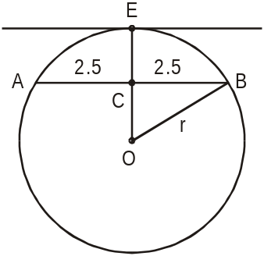

We can get the answer using the second statement only. Let the radius be r.
AC = CB = 2.5 and using statement B, CE = 5, thus OC = (r – 5).
Using Pythagoras theorem, (r – 5)² + (2.5)² = r²
We get r = 3.125

NOTE: You will realize that such a circle is not possible (if r = 3.125 how can CE be 5). However we need to check data sufficiency and not data consistency. Since we are able to find the value of r uniquely using second statement the answer is 1.

Q. 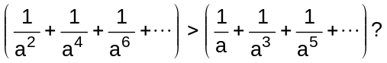
A. 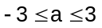
B. One of the roots of the equation 4x²–4x+1 = 0 is a

Soln. (1) — Both the series are infinitely diminishing series.
For the first series: First term = 1/a² and r = 1/a²
For the second series: First term = 1/a and r = 1/a²
The sum of the first series = (1/a²) / (1 – 1/a²) = 1 / (a² – 1)
The sum of the second series = (1/a) / (1 – 1/a²) = a / (a² – 1)
Now, from the first statement, the relation can be anything (depending on whether a is positive or negative).
But the second statement tells us, 4a² – 4a + 1 = 0 or a = ½. For this value of a, the sum of second series will always be greater than that of the first.

Q. D, E, F are the mid points of the sides AB, BC and CA of triangle ABC respectively. What is the area of DEF in square centimeters?
A. AD = 1 cm, DF = 1 cm and perimeter of DEF = 3 cm
B. Perimeter of ABC = 6 cm, AB = 2 cm, and AC = 2 cm.

Soln. (2) — The question tells us that the area of triangle DEF will be 1/4th the area of triangle ABC. Thus by knowing either of the statements, we get the area of the triangle DEF.

